Kits with coolant manifold, refer to page 5.
Kits with GEN3 delete, refer to page 6.
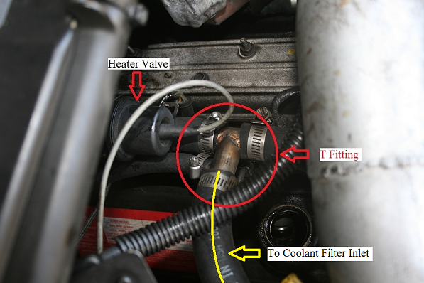Locate your passenger side inlet heater hose, cut the 3/4” hose and install the supplied T fitting included in your IPR High Flow Coolant Filter Kit. Route the heater hose marked with yellow to the inlet of the coolant filter. 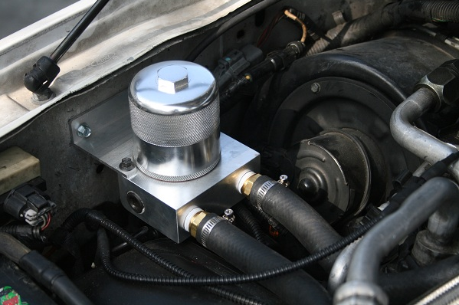Drill 2 holes on your passenger side inner fender with a 11/64 drill and mount the coolant filter with the supplied sheet metal screws. Be careful not to over torque the sheet metal screws

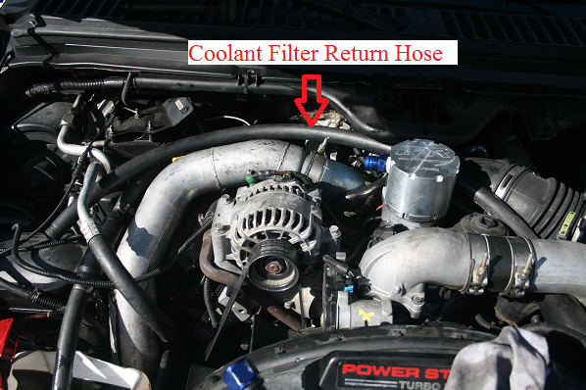
Route your coolant filter return hose to the driver side as shown. Tuck the coolant hose under the intake hose. There are other options to route your coolant return hose, please refer to the next few pages. IPR recommends routing the coolant return hose through the front of the vehicle which provides a clean installation.
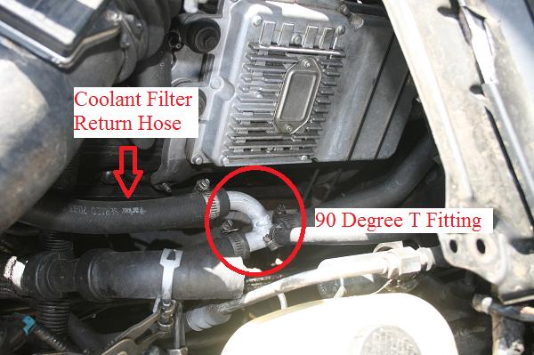Locate your heater return hose on the driver side cut the 3/4” hose and install the supplied 90 degree T fitting included in your kit.

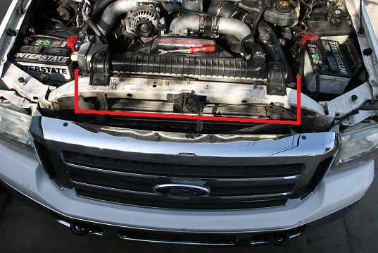To route the coolant return hose through the front of the vehicle refer to these instructions. You can route the heater hose through the passenger side by pushing the hose through the radiator core support rubber flap. The driver side may require that you trim the oem air filter inlet. Aftermaket intakes does not require this modification.
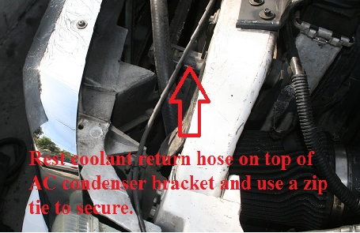
The coolant manifold can be installed without the turbo being removed. Remove the intake hose from the turbo and the turbo feed line to allow for extra space to work with. The most difficult part of the install would be removing the rear torx bolt. This can be made easier with a torx bit, a rachet drive box wrench or a 1/4 gear wrench. If none of these tools are available you can use a 12 point ¼ box wrench, this will take more time since you will have to continuously re-index your box wrench to turn the torx bit to remove the rear torx bolt.
For GEN3 EGR Delete hose routing please refer to page 6.
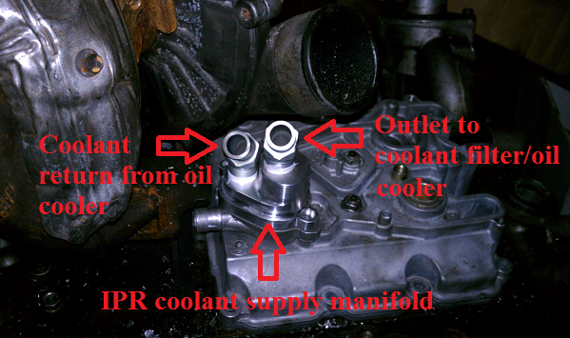

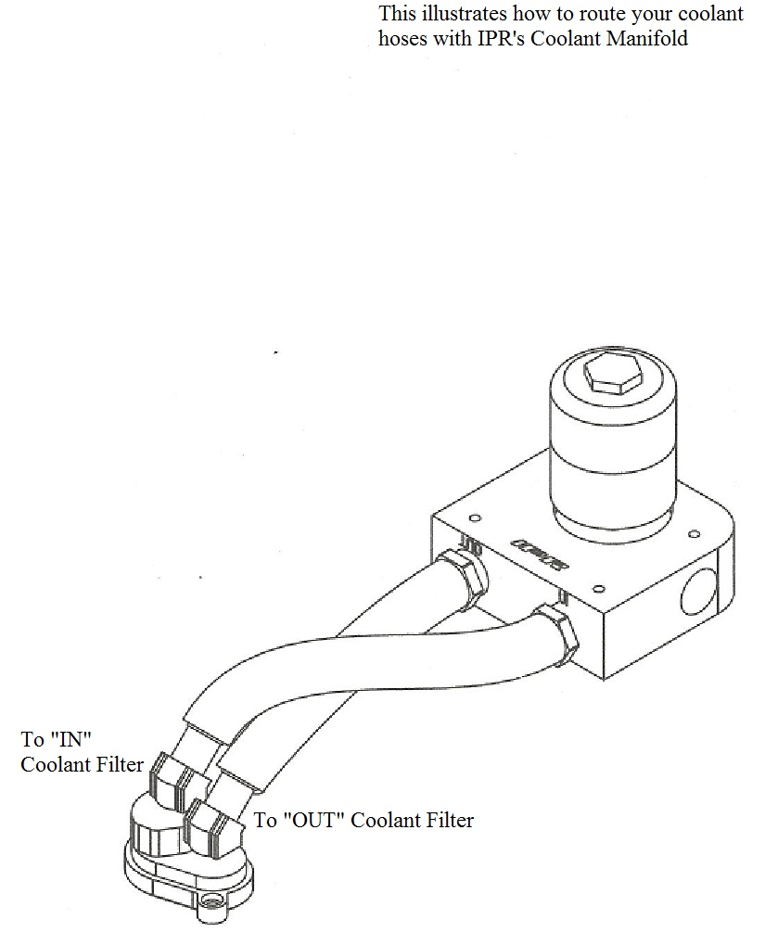

GEN3 EGR Delete hose routing diagram

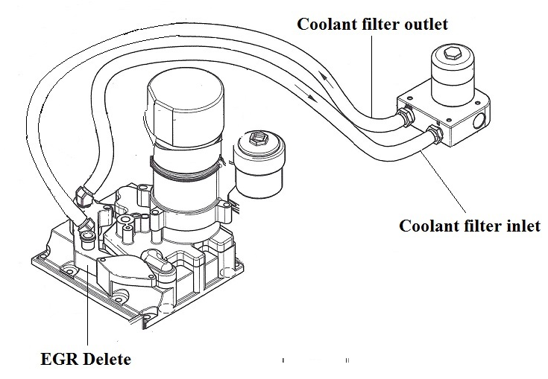

Coolant Filter Cleaning

IPR recommend that the coolant filter be inspected and cleaned every 500 miles during the first 1500 miles after the external oil cooler kit is installed. Some vehicles may be extremely contaminated with sand, rust and solidified coolant chemicals and may require more frequent service of the coolant filter. IPR recommends most house hold degreasers to clean the stainless steel element followed by a bathroom cleaner such as CLR or Limeaway and compressed air to loosen grime trapped between the pleats in the filter element. Blow with compressed air from the inside out. Brake cleaner and solvents are not recommended which may damage and cause premature wear on the coolant filter’s sealing orings and adhesives. If your vehicle is equipped with an aftermarket tuner/programmer that allows the driver to monitor oil temperatures, IPR recommend that the coolant filter be cleaned if oil temperatures are operating hotter than normal. Using a pair of hose pliers to pinch the inlet and out hoses on the coolant filter will minimize coolant loss.
If you chose to drain and lower your coolant level from the radiator drain cock it is not necessary to completely drain the coolant when servicing the coolant filter. Draining about 1 gallon of coolant below the coolant filter level will be adequate. Use a clean container when draining your coolant and reuse your coolant.
IPR highly recommend you use the coolant filter tool to disassemble the coolant filter. Never place filter housing on a vise or use channel locks to unscrew the base of the filter. This will cause damage to the sealing surface and will void your warranty. Coolant filters need only be hand tight. In most cases, once the oring comes in contact with the base, an additional 1/8 turn will create a water tight seal. Tightening the coolant filter against the base to the point where it stops turning and compressing the sealing oring usually leads to premature oring wear and will cause coolant leaks.

