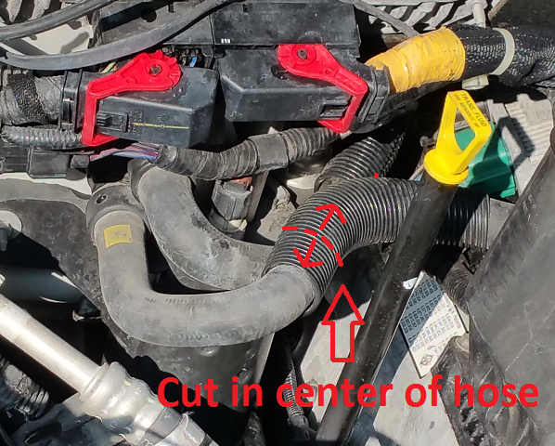
Drain the coolant from your radiator. The drain cock is located on the driver side of the radiator and can be accessed from under the truck. Remove the air cleaner box from the engine bay. Locate the heater core inlet supply hose and cut it in the center as shown on the illustration. Be sure to leave at least 1” of straight hose from the center of the cut to allow for hose clamps to be installed.

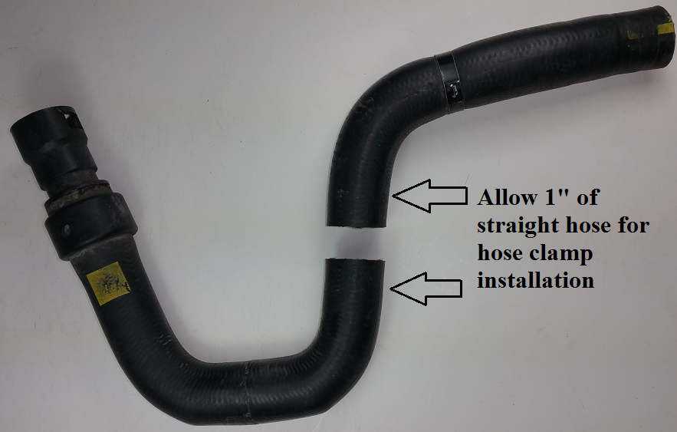

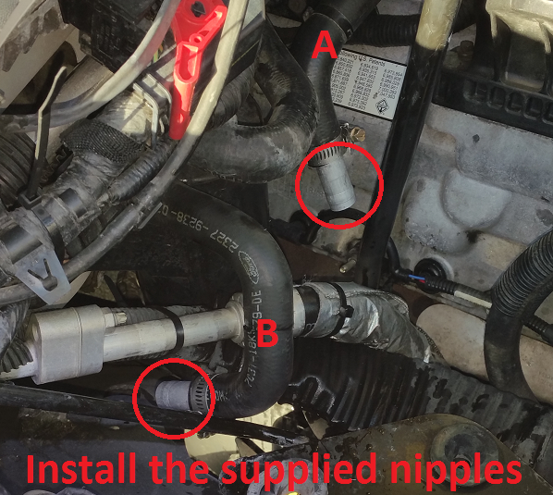
Install the supplied 3/4” nipples on both hoses and rotate the hoses 90 degrees downward so that they face towards the ground. Hose “A” will connect to the coolant filter inlet. Hose B will connect to the coolant filter outlet.
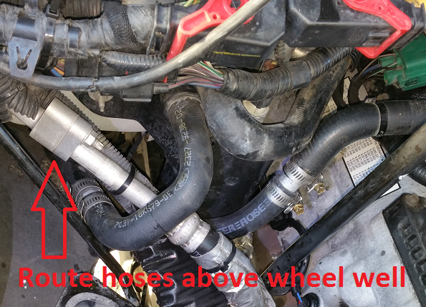
Connect the supplied heater hose and route them through the top of the wheel well. You will see an opening that will allow enough space for both hoses to be routed towards the passenger side under floor board.
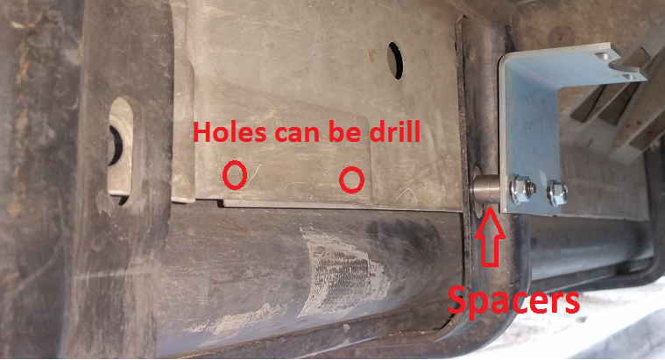
The coolant filter bracket is designed to be bolted into the factory step mount holes. The spacers provided in your kit can be used with steps that have a bump protruding from the center. The spacers can be discarded if you have steps with a flat style bracket. You can also choose to drill your own holes and mount the coolant filter against the flat surface of your inner rocker panel as shown.
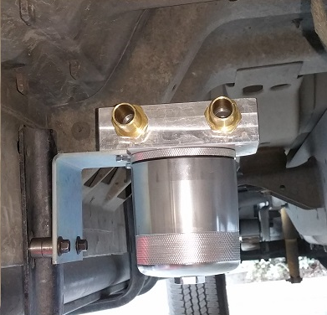
Once the coolant filter bracket has been securely fastened you can install your coolant filter as shown with the supplied 6x1.0mm bolts. Optional IPR compact ball valves part #BV750 can be ordered on our web store at www.iprresearch.com
The ball valves are highly recommended which will save you time by shutting off the coolant flow when servicing your filter.

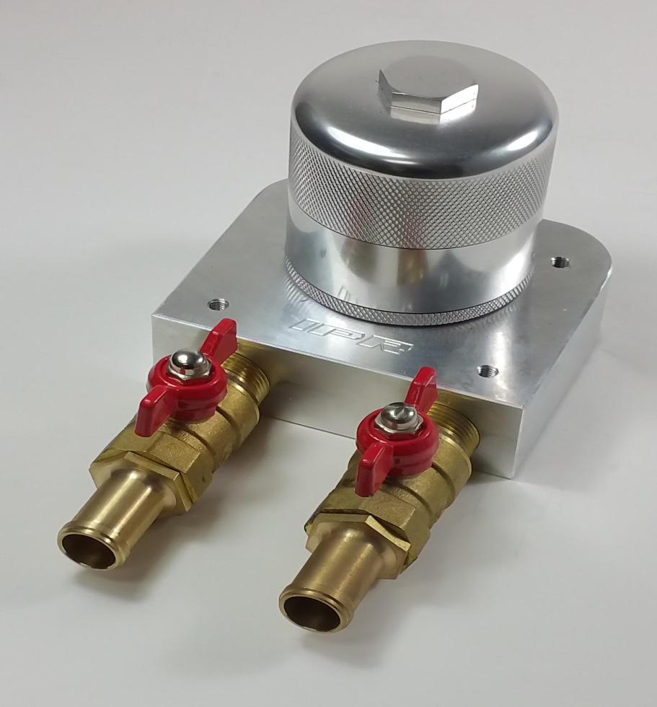
Optional ball valves shown part # BV750
Note to Simeen
Please place the options parts together side by side on one page
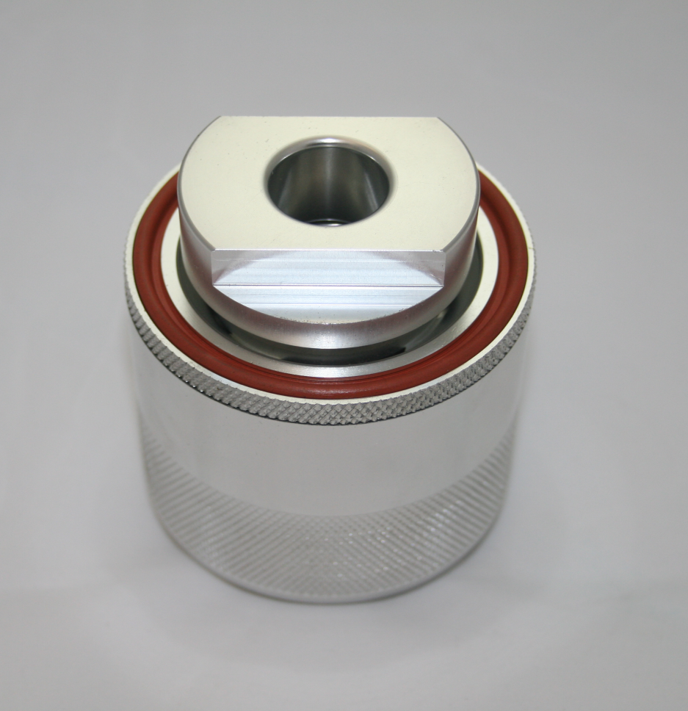
Optional coolant filter tool shown part #CM604734

Coolant Filter Maintenance
IPR recommend that the coolant filter be inspected and cleaned the first 500 miles. Some vehicles may be extremely contaminated with sand, rust and solidified coolant chemicals and may require more frequent service of the coolant filter. IPR recommends most house hold degreasers to clean the stainless steel element followed by a bathroom cleaner such as CLR or Limeaway and compressed air to loosen grime trapped between the pleats in the filter element. Blow with compressed air from the inside out. Brake cleaner and solvents are not recommended which may damage and cause premature wear on the coolant filter’s sealing orings and adhesives. If your vehicle is equipped with an aftermarket tuner/programmer that allows the driver to monitor oil temperatures, IPR recommend that the coolant filter be cleaned if oil temperatures are operating hotter than normal. Using a pair of hose pliers to pinch the inlet and out hoses on the coolant filter will minimize coolant loss, optional ball valve can be purchased on IPR’s website.
If you chose to drain and lower your coolant level from the radiator drain cock it is not necessary to completely drain the coolant when servicing the coolant filter. Draining about 1 gallon of coolant below the coolant filter level will be adequate. Use a clean container when draining your coolant and reuse your coolant.

